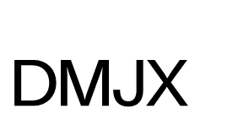

Declaration for Internship

This declaration is documentation to the Danish School of Media and Journalism that the intern has completed the internship.

The internship company´s responsibility is to sign the declaration and send it to the intern. It is the intern's responsibility to upload the signed declaration into the DMJX system.

If the internship company finds that the efforts of the intern have been of such a nature that the declaration cannot be signed, please contact the internship coordinator at DMJX

It is hereby certified that the intern (Name):

________________________________________________________________________
Date of birth (ddmmyy): _____________________________________
Education: _____________________________________________________
has completed the internship at (name of the internship company):

_______________________________________________________________________ From(ddmmyy):_____________________________________________________
Until(ddmmyy):________________________________________________________
With an average of 37 hours weekly.

____________________ ______________________________
Date On behalf of the internship company

