Danish School of Media and Journalism
Visual Communication - Creative Communication
Subject description
Spring 2023

3th semester
Brand Creation
Duration: 6 weeks (10 ECTS)

Objective
The student will work with branding and marketing of products or services. Develop and describe a communication strategy based on conducted research. The student will apply his/her theoretical foundation by working with the branding process from the first stages of research, through idea generation to the final stages of design and art direction. The student learns to manage creative processes related to branding and identity issues, as well as solving an integrated communication task.

Pedagogical and didactical approach:
The students learn to link theoretical reflection with actions in practice, as well as to reflect on and apply relevant theory and knowledge. This is done to be able to assess and qualify one's actions in a professional practice. The learning activities are based on the following fundamental Reflective Practice-based Learning principles:

No. 2: Teaching and learning activities designed to include appropriate disturbances
No. 3: Teaching and learning activities are organized as exploration
No. 4: The content of teaching and learning activities is based on the good example
No. 6: Lecturers and students create room for dialogue
The programme is structured in a combination of self-study, theoretical discussions, lectures, and group work. Both mandatory and voluntary oral feedback is given to students on assignments. Assignments are solved in groups and presented to the class where lecturers – external and staff – and the students give oral feedback. This is then reflected upon on an individual basis.
To achieve the objectives of the course, students will have to work in teams of 2. In case of an unequal number of students in the class, the lecturer in charge will decide which team will consist of three students.

Tools:
Analysis, layout, mood boards, campaign flow, preparation of design variants/solution proposals.

Learning outcomes
Students should gain knowledge of:

- The value of branding
- Visual and verbal identity
- Development of brand name
- Conceptual packaging
- Creative strategies
- Branding: SoMe
- Brand campaigns
- Brand evaluation
- Presentation creation

At the end of the course, students should have skills in

- Team collaboration
- Efficacy in analysis and research
- Working with tools for strategic and creative thinking
- Learn to develop, refine, and evaluate strategies and ideas
- Learn to present their work and ideas effectively

At the end of the course, students should have competencies in:

- Efficacy in analysis and research
- Developing a cohesive brand
- Developing coherent brand communications across media and platforms
- Developing creative interactions between consumer and brand
- Presenting brand campaigns

Learning Resources:
Literature - provided:

Horberry, Roger & Lingwood, Gyles (2014). Read Me. Laurence King Publishers
Johnson , Michael (2016). Branding in five and a half steps. Thames & Hudson
Neumeier, Marty (2014). The Brand Gap. New Riders
Neumeier, Marty (2016). Zag. New Riders
Olins, Wally (2010). The Brand Handbook. Thames & Hudson

Material in the form of slides from the course lectures with relevant theories

Mandatory attendance/participation:
Attendance is compulsory for all scheduled classes. Participation is compulsory in exercises, group work, tutorials, joint feedback, and summaries.

Preconditions for the exam:
Meeting the exam prerequisites is a requirement for the student to participate in the course exam. Examination prerequisites may include attendance, participation, group work, assignments, papers, presentations, etc. Failure to meet an examination prerequisite will result in the student failing an examination attempt.

Mandatory attendance:
Attendance is mandatory for the course. The learning system itslearning indicates Physical attendance at school is compulsory on all school days. If, in exceptional cases, attendance is not compulsory for teaching or learning activities, this is indicated with a "FF" (voluntary attendance) in the itslearning system.

Compulsory participation:
Participation is compulsory in group work and feedback.

Remedial options:
In case of legal absence, remediation applies.

Substitute assignments:
Absences from teaching and learning activities may be replaced by one or more assignments if the teacher deems it possible. If the student's absence from teaching and learning activities is deemed excessive in relation to the content and learning objectives of the course, the course must be rescheduled.

Examination:
Assessed by 7-point scale and internal grading.
Examination format: The course ends with a creative solution and a report, in which the student documents his/her competences to independently analyze, assess, document, and solve communication problems. 20 minutes oral examination, including voting (+10 min for 2-person group examination).

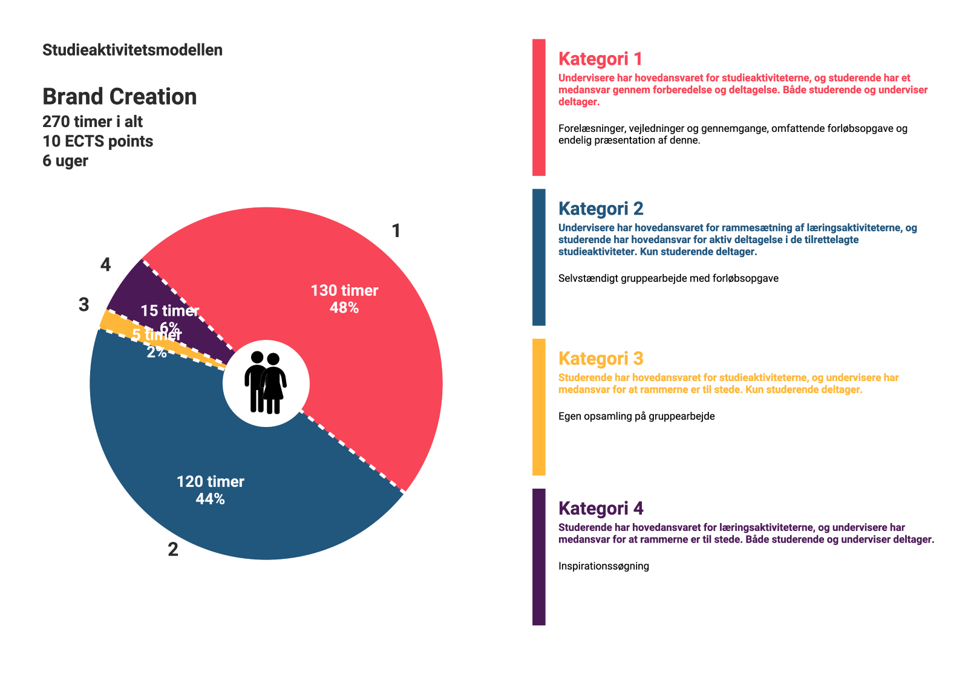
Godkendt af NN, august 2023

