**Danish School of Media and Journalism**

**Corporate Communication //**

**Sustainability communication - Theories and practical approaches to communicating a trustworthy image of the organization as a responsible actor in society**

**Course description**  
**Spring semester 2023**

**Course:** CSR – concepts, strategies and communication of sustainability

**5. semester**

**Number of ECTS Credits:** 10 ECTS

**Aims:**

The first course of this semester focuses on introducing students to the different conceptualizations and understandings of CSR and sustainability, both in terms of the historical as well as its conceptual development. We will discuss the role of CSR and sustainability in society, a society which increasingly demands and expects organizations to engage in sustainability and behave responsibly. This further entails that we will explore what the social responsibility of the organization may entail (role, characteristics and challenges), the importance of sustainability and social responsibility in relation to developing and strengthening the values and ethics of the organization – and of course not least the opportunities and challenges faced by organizations communicating CSR. This first course of the semester also contains an introduction to sustainable business models, the ideas behind circular economy and the different methods of reporting in both annual and sustainability reports.

**Pedagogical and didactic approaches:**

This first course has the purpose of introducing students to the vast field of CSR and sustainability and provide them with the knowledge and understanding required in order to work with the topics in a professional, critical and practical manner in the later courses of the semester. Therefore, the focus of the teaching is on enabling students to *understand, identify and recognize* theories and concepts about CSR, sustainability and sustainable business models as they play out in practice.

Throughout the course, classes will thus include both lectures, class exercises, group work, student presentations and written assignments. Students are expected to prepare for classes (e.g. read literature, work on cases, discuss theories and cases in the study group, prepare presentations, etc.) and to participate actively in classes. The teaching and the content of the courses this semester require a high degree of independent work from the students, and that they engage in reflecting on the theories and approaches discussed as well as on their own learning process.

**Working methods:**

**Learning outcomes:**

The students will obtain the following during the course:

The students will obtain knowledge and understanding of:

* Corporate Social Responsibility and Sustainability definitions
* Approaches to CSR and sustainability organization and strategy
* CSR and sustainability communication
* Challenges and opportunities related to CSR and sustainability communication
* CSR and sustainability in branding
* Sustainable business models
* Circular economy
* Reporting
* ESGs and SDGs

The student will obtain skills in:

* Recognizing, identifying and analyzing organizations’ use of CSR and sustainability approaches in their strategic communication
* Understanding and discussing organizational choices in terms of sustainability and CSR with a view to suggesting alternative choices
* Identifying and discussing potential communicative challenges and opportunities for organizations engaging in and communicating about CSR and sustainability.
* Reading and understanding corporate material about CSR/sustainability reporting.

The student will obtain competences in:

* Suggesting and arguing for alternative choices of CSR strategy, communication and reporting based on independent analysis and research.

**Literature** (hand out):

Andersen et al. (2017). Communicative Dilemmas of CSR: Towards and Integrative framework of CSR communication. In Diehl et al.: *Handbook of Integrated CSR Communication*, pp. 51-69.

Blowfield & Murray (2019). *Corporate Social Responsibility*. Chapter 1: Introducing

CSR, pp. 4-28.

Borglund et al. (2021): *CSR and sustainable business*, 2nd edition. Chapter 7: Sustainable consumption, marketing and consumers, pp. 190-221.

Bruhn & Zimmermann (2017). Integrated CSR Communications. In Diehl et al., *Handbook of Integrated CSR Communication*, pp. 3-21.

Brunner & Langner (2017). Communicating Corporate Social responsibility for Brands. In Diehl et al., *Handbook of Integrated CSR-Communication,* pp. 149-169.

Carroll (1991). The Pyramid of Corporate Social Responsibility: Toward the Moral Management of Organizational Stakeholders. *Business Horizons*, 34(4):39-48.

Carroll (2016). Carroll’s Pyramid of CSR: taking another look*. International Journal of Corporate Social Responsibility*, 1(3): 1-8.

Carroll (2021). Corporate Social Responsibility: Perspectives on the CSR Construct’s

Development and Future. *Business & Society*, *60*(6), 1258-1278.

Carroll & Brown (2018). CSR: A Review of current concepts, research and issues. In (Weber & Wasielesky, eds.) *Corporate Social Responsibility*, chapter 2: pp. 39-69.

Chandler (2020). *Strategic Corporate Social Responsibility. Sustainable Value Creation, 5th edition*, chapter 10: 240-257 (Strategic CSR).

Crane & Glozer (2016). Researching Corporate Social Responsibility Communication: Themes, Opportunities and Challenges. *Journal of Management Studies, 53*(7): 1223-1252.

de Jong, Huluba & Beldad (2020). Different shades of greenwashing: Consumers’ Reactions to environmental Lies, Half-Lies, and Organizations Taking Credit for Following Legal obligations. *Journal of Business and Technical Communicat*ion, 34: 38-76.

Elkington (2018). 25 Years Ago, I Coined the Phrase “Triple Bottom Line.” Here’s Why It’s Time to Rethink It. *Harvard Business Review*, June issue. Available online at: <https://hbr.org/2018/06/25-years-ago-i-coined-the-phrase-triple-bottom-line-heres-why-im-giving-up-on-it>

Golob et al. (2017). The communicative stance of CSR: reflections on the value ofCSR

communication. *Corporate Communications: An International Journal*, *22*(2),166-177.

Golob & Podnar (2018). Researching CSR and brands in the here and now: an

Integrative perspective. *Journal of Brand Management*, *26*(1): 1-8.

Gulati (2022). The Messy bur Essential Pursuit of Purpose. *Harvard Business Review*. March-April Issue. Available online at: <https://hbr.org/2022/03/the-messy-but-essential-pursuit-of-purpose>

Gulbrandsen, Just & Uldam (2020). S(t)imulating Resistance. Corporate responses to the Trump presidency. *Organization,* 1-23.

Hanson et al. (2018). Society or the environment? Understanding how consumers evaluate brand messages about corporate social responsibility activities. *Journal of Brand Management*, 26: 21-34.

Iglesias & Ind (2020): Towards a theory of conscientious corporate brand co-creation:

the next key challenge in brand management. *Journal of Brand Management*, 27: 710

720.

Knowles et al (2022). What is the purpose of your purpose? *Harvard Business Review*, March-April Issue. Available online at: <https://hbr.org/2022/03/what-is-the-purpose-of-your-purpose>

Matten & Moon (2008). "Implicit" and "Explicit" CSR: A Conceptual Framework for a Comparative Understanding of Corporate Social Responsibility. *The Academy of Management Review*, 33 (2): 404-424.

Matten & Moon (2020). Reflections on the 2018 Decade Award. The Meaning and Dynamics of Corporate Social Responsibility. Academy of Management Review, 45(1): 7-28.

Morsing & Schultz (2006). Corporate social responsibility communication: Stakeholder information, response and involvement strategies. *Business Ethics: A European Review*, 15(4): 323-338.

Morsing, Schultz & Nielsen (2008). The ‘Catch 22’ of communicating CSR: Findings from a Danish study. *Journal of Marketing Communications*, 14: 97-111.

Olkkonen & Morsing (2022). A Processual Model of CEO Activism: Activities, Frames, and Phases. *Business & Society*, 1.49.

Porter & Kramer (2011). Creating Shared Value – How to reinvent capitalism – and unleash a wave of innovation and growth. *Harvard Business Review*, 89(1-2):62-77.

Schmeltz (2012). Consumer-oriented CSR communication: focusing on ability or morality? *Corporate Communications: An International Journal*, 17(1): 29-49.

Schmeltz (2012A). *Defining CSR.* In *Conflicting Values in Discourses of Social Responsibility. Essays on Consumer-Oriented CSR Communication*. PhD Dissertation. Excerpt: pp. 13-22.

Schmeltz (2012B). *Defining CSR Communication.* In *Conflicting Values in Discourses of Social Responsibility. Essays on Consumer-Oriented CSR Communication*. PhD Dissertation. Excerpt: pp. 25-31.

Schmeltz (2014). Identical or Just Compatible? The Utility of Corporate Identity Values in Communicating Corporate Social Responsibility. *International Journal of Business Communication*, 51(3):234-258.

Schmeltz (2017). Getting CSR-communication fit: A study of strategically fitting cause, consumers and company in corporate CSR communication. *Public Relations Review*, 6: 47-72.

Schmidt, Ind, Guzmán & Kennedy (2022). Sociopolitical Activist Brands. *The Journal of Product & Brand Management*, 31(1): 40-55.

Schoeneborn, Morsing & Crane (2019). Formative Perspectives on the Relation

Between CSR Communication and CSR Practices: Pathways for Walking, Talking, and

T(w)alking. *Business & Society*, 59(1): 5-33.

Schwartz & Carroll (2003). Corporate Social Responsibility: A Three Domain Approach. *Business Ethics Quarterly*,13(4): 503-530.

Vredenburg et al. (2020). Brands taking a stand: Authentic brand activism or woke washing? *Journal of Public Policy and Marketing*, 39(4): 444-460.

Weder et al. (2019). Heading for new shores. Impact orientation of CSR communication and the need for communicative responsibility. *Corporate Communications, An International Journal*, 24(2): 198-211.

Weder & Karmasin (2017). Communicating Responsibility: Responsible Communication. In Diehl et al., *Handbook of Integrated CSR Communication,* pp. 71-86.

Williams (2019). The business case for purpose. In (Montgomery, ed) *Perspectives on Purpose – Leading Voices on Building Brands and Businesses for the Twenty-First Century*. Chapter 1, pp. 9-17.

**Literature** (available online):

Edelman (2023). 2023 *Edelman Trust Barometer – Navigating a polarized world*. Edelman.com. Available online at: <https://www.edelman.com/trust/2023/trust-barometer>

Ind (2021). *Consumers expect brands to take a stance on key issues*. Available online at: <https://www.kristiania.no/kunnskap-kristiania/2021/08/consumers-expect-brands-to-take-a-stance-on-key-issues/>

Sustainable Brand Index (2023). *Sustainable Brand Index Report, DK*. Available at: <https://www.sb-index.com/denmark>

**Prerequisites for taking the exam:**

Fulfilling the requirements mentioned here is a prerequisite for the students to take the exam. Failing to fulfill requirements counts as a used examination attempt.

Compulsory attendance: All scheduled classes are compulsory.

Compulsory participation:

Assignments: All obligatory assignments are compulsory and must be submitted in time and approved.

Group work: Participation in assigned group work is also compulsory.

Remediation

The possibility for remediation only applies in cases of lawful absence.

Substitute assignments: Scheduled classes can be substituted by one or more written assignments if the lecturer finds it necessary. This is always based on specific and individual assessment. If the student has more than 30% absence in scheduled classes, the student must resit the course.

**Exam/Grading:**

The course is assessed through an individual written exam paper, using the Danish 7-point grading scale (internal assessment).

**Study Activity Model:**

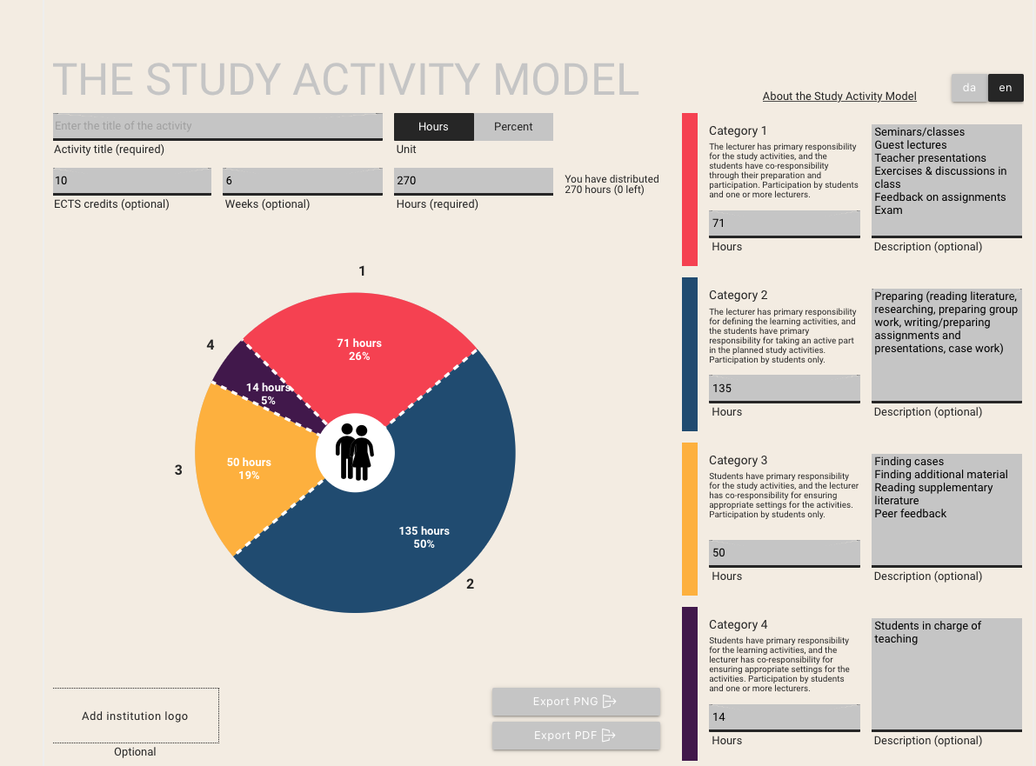

*MIB, 28.08.23*