**Danish School of Media and Journalism**

**Corporate Communication**

**Course description**

**Fall semester 2023**

**Course:** Execution of CSR and sustainability communication

**Number of ECTS Credits:** 10 ECTS

**Aims:**

In the last course of the semester, you will work in practice with a case related to communication of CSR and sustainability for which you will need to draw on your knowledge acquired in the first two courses of the semester. In other words, you get the opportunity to apply your newly attained knowledge, skills and competences within the field in practice on a real-life case for which you will get feedback from both your professors and the case company. The course also looks at how organizations can communicate responsibly, and how message strategies, media choices and creative strategies both contribute to the overall CSR strategy and to the communication of it. The final project gives you the opportunity to define a communication brief, develop a creative idea and product, and determine a message and media strategy.

**Pedagogical and didactic approaches:**

This last course of the semester has the purpose of finally introducing the students to the operational level of CSR-communication. The course provides the students with the knowledge, skills and competences required to communicate responsibility on a practical level, and to do so in a responsible manner. Focus is placed on the considerations, possibilities, and challenges, related to practical CSR-communication, and how they influence the communication process, from; identifying a relevant problem, and in relation to that deveopling relevant and strong insights, to crafting a creative brief and finally executing and evaluating the effect of the communication through relevant and responsible KPIs.

The course introduces a real-life case, to which lectures, class exercises, group work, student presentations and assignments are all continuously related. By giving students the opportunity to immediately *operationalize their acquired knowledge to a real-life case,* the course enables students to actively practice and progressively develop their communicative skills, in collaboration with the case, professors and co-students, as well as gradually develop an overall understanding and first-hand experience of the process of operationalizing strategic CSR-communication.

**Working methods:**

Students are expected to prepare for classes (e.g. read literature individually, as well as participate in and contribute to the ongoing group work outside of classes, i.e. discuss theories and solutions in relation to the overall case, perform research, develop and test communicative and creative solutions, prepare presentations etc.) and to participate actively in classes. The teaching and the content of this course thus requires a high degree of independent as well as group work from the students as well as high level of participation.

**Learning outcomes:**

The students will obtain the following during the course:

Knowledge about:

* Trends and current developments within practical CSR communication, especially message strategies, creative strategies, and choice and use of media
* Causes of sceptizsm towards CSR and how communicatuion can counter distrust
* Different strategies to creating communicative credibility and trust
* Characteristics and qualities of different media, in relation to communicating responsibility
* The proces of developing a creative brief, and the sub-elements of that process
* How practical, operational CSR-communication, can connect to and influence the overall corporate strategy and brand

Skills in:

* Developing a creative brief, i.e.:
  + Identifying and qualifying creative insights
  + Identifying and qualifying a target audience
  + Developing and qualifying a creative concept
  + Developing responsible meassage strategies
  + Making responsible media choices and combining media in an effective as well as responsilbe cross-media strategy
  + Identifying relevant and responsible KPIs for the communication effort
* Crafting and executing creative and responsible communication
* Presenting the creative brief via both the brief-, and pitch-format

Competences in:

* Practical communication of corporate social responsibility
* Execution of complex communication strategies
* Critical reflection and independent application of theories and methods within the field of strategic CSR-communication

**Literature** (hand out):

* Berens, G. & Rekom, J.V., 2008: How specific should corporate communication be? The role of advertising language in establishing a corporate reputation for CSR, in Melewar, T.C. *Facets of Corporate Identity, Communication and Reputation*, pp: 96-120
* Brunk, K.H., & Boer, C.D., 2020. How do Consumers Reconcile Positive and Negative CSR-Related Information to Form an Ethical Brand Perception? A Mixed Methods Inquiry. In: *Journal of Business Ethics,* vol 161, s. 443-458
* Brunner, C.B. & Langner, T., 2017. Communicating Corporate Social responsibility for Brands. In: Diehl et al., 2017. *Handbook of Integrated CSR-Communication, CSR, Sustainability, Ethics & Governance*. S.l.: Springer International, s. 149-169
* Etter, M., 2014. Broadcasting, Reacting, Engaging - Three strategies for CSR- communication in Twitter. In: *Journal of Communication Management*, 18(4), s. 322-342
* Gass, R.H. & Seiter, J.S., 2018. *Persuasion – Social influence and compliance gaining*, New York: Routledge, pp. 84-97
* Grant. J. 2020. Greener Marketing. Wiley, pp. 39-48
* Hanson, S., Jiang, L., Ye, J. & Murthy, N. 2019. Society or the environment? Understanding how consumers evaluate brand messages about corporate social responsibility activities. In: *Journal of brand Management*. vol. 26, s. 21–34
* Iglesias, O, Markovic, S., Bagherzadeh, M., & Singh, J.J., 2018. Co-creation: A Key link between corporate social responsibility, customer trust, and customer loyalty. In: *Journal of Business Ethics,* onlinefirst
* Jing (Taylor), W., & Song, B., 2017. Corporate Ethical Branding on YouTube: CSR Communication Strategies and Brand Anthropomorphism. In: *Journal of Interactive Advertising,* vol. 17:1, s. 28-40
* Kollat., J. & Farache, F., 2017. Achieving consumer trust on Twitter via CSR communication. In: *Journal of Consumer Marketing*, vol. 34(6), s. 505-514
* Lee, J. & Cho, M. 2018. New insights into socially responsible consumers: The role of personal values. In: *International Journal of Consumer Studies*, vol. 43. S. 123-133
* Maslen, A. 2015. Persuasive copywriting, Finding your voice (and that of others)
* McGovern, G. 2021. *World Wide Waste. Why digital is killing our planet – and what we can do about it*. introduction: [Introduction: Why digital is killing our planet - Gerry McGovern](https://gerrymcgovern.com/books/world-wide-waste/introduction-why-digital-is-killing-our-planet/)
* Nilssen, R., Bick, G. & Abratt, R. 2019. Comparing the relative importance of sustainability as a consumer purchase criterion of food and clothing in retail. In: *Journal of brand Management*, vol. 26, s. 71-83
* Radley Yeldar, n.d. *Words that work – effective language en sustainability communication*. [Words that work: effective language in sustainability communications | Radley Yeldar (ry.com)](https://ry.com/thinking/words-that-work/words-that-work-effective-language-in-sustainability-communications)
* Saxton, G.D., Gomez, L., Ngoh, Z., Lin, Y. & Dietrich, S., 2019. Do CSR Messages Resonate? Examining Public Reactions to Firms’ CSR Efforts on Social Media. In: *Journal of Business Ethics*, vol. 155, s. 359-377
* Schmeltz, L., 2014. Identical or Just Compatible? The Utility of Corporate Identity Values in Communicating Corporate Social Responsibility. In: *International Journal of Business Communication*, s. 1.25
* Young, J. 2013. A Conceptual Understanding of Organizational Identity in the Social Media Environment, in; *Advances in Social Work*, vol. 14, 2, pp. 518-530

**Prerequisites for taking the exam:**

Fulfilling the requirements mentioned here is a prerequisite for the students to take the exam. Failing to fulfill requirements counts as a used examination attempt.

Compulsory attendance: All scheduled classes are compulsory.

Compulsory participation:

Assignments: All obligatory assignments are compulsory and must be submitted in time and approved.

Group work: Participation in assigned group work is also compulsory.

Remediation

The possibility for remediation only applies in cases of lawful absence.

Substitute assignments: Scheduled classes can be substituted by one or more written assignments if the lecturer finds it necessary. This is always based on specific and individual assessment. If the student has more than 30% absence in scheduled classes, the student must resit the course.

**Exam/Grading:**

The course is assessed through an oral group exam, using the Danish 7-point grading scale (internal assessment). The exam consists of a group presentation, followed by questions and dialogue. The groups for the exam are the same as the study groups during the course, which are composed by the institution The duration of the exam is 15 minutes per students, including grading and feedback, with a minimum of 25 minutes, and a maximum of 75 minutes per group. The student receives individual evaluation.

**Study Activity Model:**

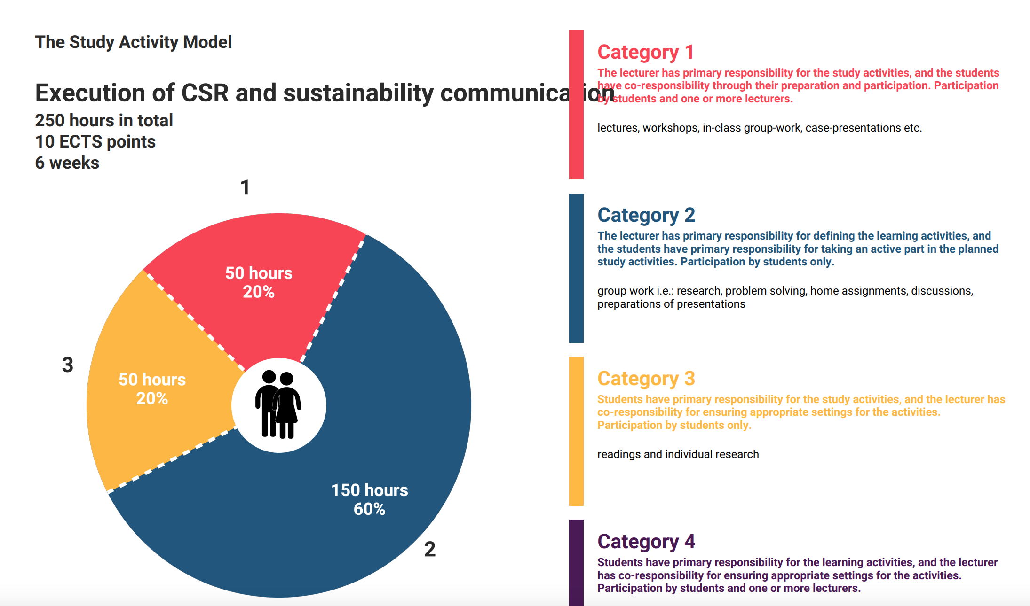

*MIB, 24.08.23*