**Danish School of Media and Journalism**

**TV and Media Production**

**Course description  
Fall semester 2023  
Visual Storytelling**

**3rd semester**

**Number of ECTS Credits:** 5

**Aims:**

The objective of the Visual Storytelling course is to give students basic knowledge of, and skills in, producing sharply structured narratives in moving images and sound. Students will be trained in finding the focus of a story, they will be introduced to dramaturgic models and structuring tools. Furthermore, the students will learn basic techniques and tools for visual narratives. Students will get instruction and training in basic camera work, sound recording and editing skills.

**Pedagogical and didactic approaches:**

Lectures, literature, and online courses introduces the students to the language, theories and tools needed to tell a story. Analyzing of theory and film examples in class gives students an understanding of storytelling, a language, and a common frame of reference. The course will give students practical experience through idea research, video production and group work preparing students with the skills needed for the rest of the semester at TVM. Supervision and feedback between students secure guidance throughout the process.

Students will work in groups that are put together by the lecturer.

**Tools:**

Camera and sound equipment; editing and postproduction applications; video tutorials.

**Learning outcomes:**

The students will obtain the following during the course:

Knowledge and understanding:

* How to plan, shoot and edit a short video

Skills:

* Structure a short and simple linear narrative/ video production.
* Record images and sound.
* Edit a short and simple video story.
* Formulate an angle on and a focus in a linear narrative/video production.

Competences:

* Generate relevant ideas for short video productions.
* Cooperate in teams doing analysis, exercises and video productions.
* Give and receive feedback to and from fellow students and tutors in a compe-tent and respectful way.

**Literature** (hand outs):

* Thompkins, A. (2012). Aim for the heart. CQ Press. Pages 1-14; 97- 04.
* Everton, N. (2004). The VJ Handbook. CBC Learning and development. Pages 31-33; 35-39.
* Block, B. (2008). The Visual Story. Focal Press. Pages 2-8; 24-30; 58-59; 67-70.

**Literature** (available online):

LinkedIn Learning video tutorials:

* The importance of understanding exposure (part 1). Ben Long
* Premiere Pro CC 2022 Essential Training: The Basics. Ashley Kennedy, chapter 1-4 and
* Fixing color and exposure problems in video with Premiere Pro. Richard Harrington.

**Preconditions for the exam:**

Fulfilment of attendance requirements and/or submission of assignments and projects etc. are required for being allowed to take an examination. In this course the preconditions are:

Participation: Participation in group work and supervision is required  
Compensation: If a student does not participate in group work and supervision sessions the student must hand in compensation assignments as a precondition for exam.

**Exam**

Graded using the ECTS scale with an internal examiner.

Exam: In groups of two or three people the students will produce a video and make a short presentation of their choices. The production is examined orally, with a maximum of 15 minutes per student, including the grading. The grade is determined both by the production and the presentation.

**Study Activity Model:**

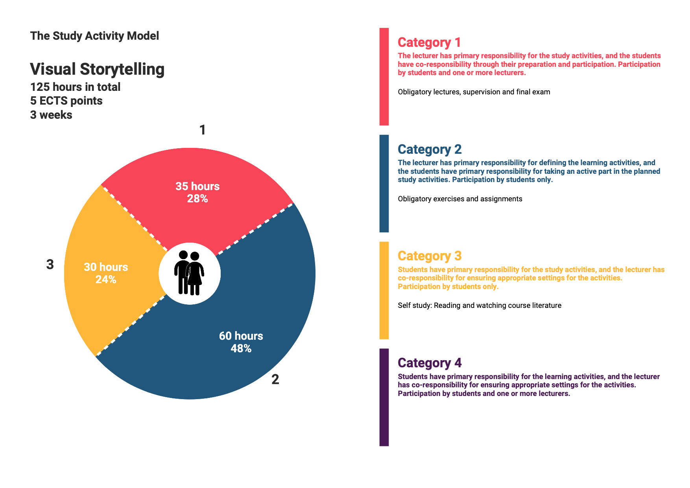

Approved by BBS, 2023-08-14