Danish School of Media and Journalism
TV and Media Production
Course description
Fall semester 2023
Reality and entertainment formats
3rd semester

Number of ECTS Credits: 5 ECTS

Aims:
This course introduces students to the development of formats in the reality and entertainment genres. Students are introduced to the concept of formats, to development of ideas and to the pitch process for broadcasters and streaming services. The exam assignment is based on electives, where students can use local conditions or genre interests to influence their assignment.

The course will introduce and explain the different subgenres within this field of TV content, and train students in developing treatments and pitch material.

The course is planned as an online course. Students do not need to be physically present in Denmark for classes or exams.

Pedagogical and didactic approaches:
All teaching and supervision will be done online, to accommodate students who are outside Denmark during the course.

Students will work in groups that are put together by the lecturer.

Learning outcomes:
The students will obtain the following during the course:

Knowledge and understanding:
- Basic knowledge of unscripted TV formats, their history and genre classification

Skills:
- Basic skills in insight-based development processes

Competences:
- Developing original format ideas
- Developing and pitching in teams

Literature (to be purchased before the course begins):
Green, L., Marshall, H. and Miller, C. (2022). Creating TV Formats - From Inception to Pitch. Taylor and Francis.

Literature (hand out):
Bazalgette, P. (2005): Billion Dollar Game – how three men risked it all and changed the face of Television. Time Warner Books. Pages 1-4 and 52-77
Boross, P. (2012): The Pocket Pitching bible. CGW Publishing. Pages 8-13 and 16-38
Fey, C. (2005): Trading TV Formats. EBU. Pages 63-81

Preconditions for the exam:
Fulfilment of attendance requirements and/or submission of assignments and projects etc. are required for being allowed to take an examination. In this course the preconditions are:
Participation: Participation in online group work and supervision is required.
Compensation: If a student does not participate in group work and supervision sessions the student must hand in compensation assignments as a precondition for exam.

Exam:
Graded using the ECTS scale with an internal examiner.
The course is examined orally in a pitch format, where students present in groups of three to four students. The exam has a maximum duration of 10 minutes per student, including grading.

Study Activity Model:
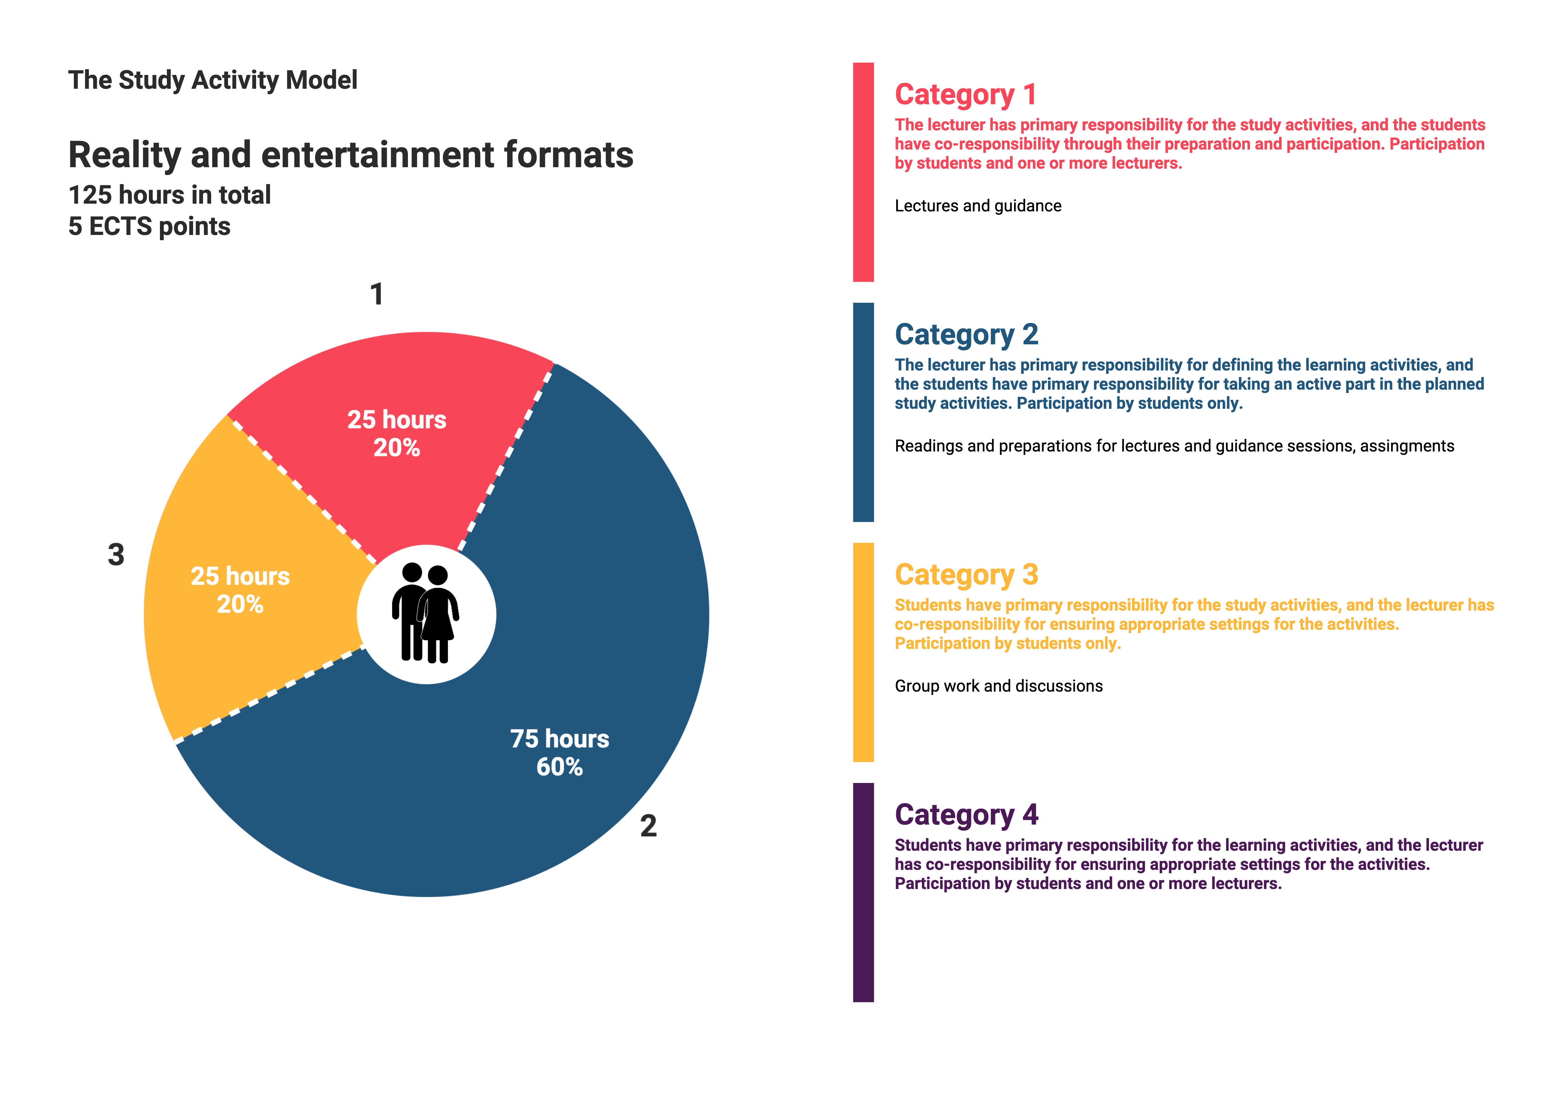
Approved by BBS, 2023-04-04.

