**Danish School of Media and Journalism**

**Course description**

**Fall semester 2023**  
**International Video Journalism**

**3rd. semester**

**Number of ECTS Credits:** 30 ECTS

**Aims**

This one-semester, full-time programme combines practical video journalistic training with theoretical studies. Through visual storytelling and reflective reporting students will learn to produce journalistic video features and a short documentary video story.

**Pedagogical and didactic approaches**

Lectures with interactive discussions and exercises in groups based on the readings and relevant videos. Group work and peer feedback are the working methods for all the video assignments, including individual tuition in groups. Re-editing every video assignment based on the feedback given by teachers and peers.

The practical assignments given become gradually more complex in content and form and are followed, in steps, by analytical academic lectures and more comprehensive written reflective assignments. The theoretical-practical application of teaching and learning offers students a clear progress in journalistic experience and theoretical knowledge.

The group work and peer feedback will give the students a possibility to develop individually through cooperation and reflection on their working processes.

**Working methods:**

Research, planning and production of Journalistic video feature stories.

Lectures, groupwork, class discussions, self-study of texts and video documentaries.

Digital camera, video editing software and a variety of applications for info graphic design are the technical tools available for the students.

**Learning outcomes:**

The students will obtain the following during the course:

Knowledge and understanding:

* Gain knowledge on the opportunities and ethical challenges in using social media in research, and for publishing video stories.
* Obtain increased knowledge of Danish political, social and cultural current affairs.
* Know how statistics can be the point of departure for production of current affairs stories.
* Try out different ways of working in a creative process with video storytelling

Skills:

* Develop journalistic video skills by studying in an international context with students from all over the world.
* Develop critical self-reflection skills in regard to the production processes.
* Master how to shoot with a story with digital HD camera and how to edit video using Final Cut ProX software.

Competences:

* Practical experience in the working process of planning and producing video stories in groups.
* Know the characteristics and demands of journalistic video formats.

**Literature**:

Tompkins, A. (2018) Aim for the Heart, (3rd.edition) Sage Publications.

Das, T. (2007). How to Write a Documentary Script, Public Service Broadcasting Trust, UNESCO

Thompson, R./ Bowen, C. J. (2009). Grammar of the Shot, 2nd Edition. Focal Press

Calver, B., Kemp, D., Ryder, M. (2017). Everybody In. Leanpub, Birmingham City University School of Media.

**Literature** (available online):

documentarystorm.com

**Attendance:**

All lectures, assignments, group work, coaching and evaluations of assignments are mandatory.

**Preconditions for exams:**

Students must meet the examination prerequisites in order to participate in the examination for each course of the programme. Prerequisites are compulsory attendance, compulsory participation, group work, assignments, presentations, etc.

A student who do not fulfill the examination prerequisites will not be able to attend the exam, and have used one exam attempt for that particular course.

See the individual courses for the specific requirements.

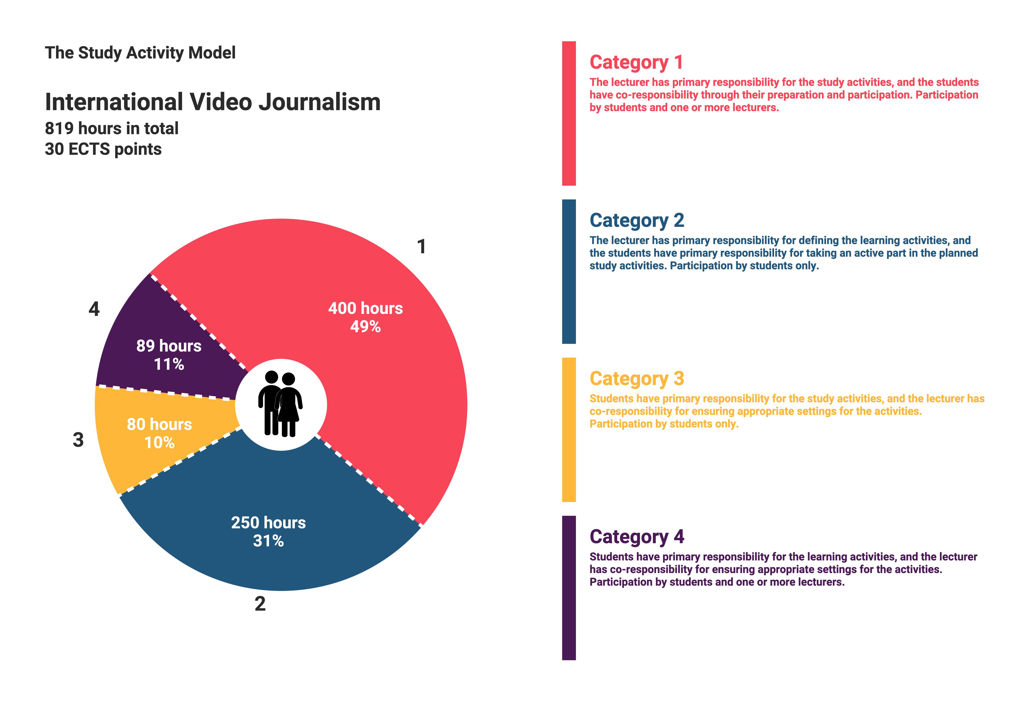

**The program consists of three courses:**

**Course Description**

**Feature Journalism**

**Number of ECTS Credits: 10 ECTS**

# Aims

# Enable the students to master methods to achieve the skills of research, production and analysis of feature video stories.

# Introduce and discuss specific methods to gather information

# Plan, record and edit different types of feature stories.

# Collaborate with fellow students in a group

**Pedagogical and didactic approaches**

Lectures with interactive discussions and exercises in groups based on the readings and relevant videos. Group work and peer feedback are the working methods for all the video assignments, including individual tuition in groups. Re-edit the video assignment based on the feedback given by teachers and peers.

**Working methods:**

Research, planning and production of Journalistic video feature stories.

Lectures, groupwork, class discussions, self-study of literature, video features and video documentaries.

**Learning outcomes**

On completion of the course, students are expected to have achieved:

**Knowledge**

* Know the methodology of feature video production: Different research techniques, source critique and story structures.
* Know how articulated pictures, visual storytelling and natural sound, contribute to information, fascination and identification.
* Know different forms of storytelling templates and the characteristics of the formulas.
* Know how to research and plan a feature video story.
* Know the importance of thorough research and journalistic ethical awareness of the workflow and its outcome.

**Understanding**

* Understand the characteristics of feature video stories and criteria for choosing a relevant angle, content and use of credible sources.
* Understand how to critically analyse sources and how to develop a focus that corresponds to the target audience.
* Understand the different characteristics of short- and long format stories.
* Understand different dramaturgical storytelling templates used in international video reporting.
* Understand the importance of cooperation in video production.

### Skills

* The students will be able to produce feature stories by using relevant journalistic criteria and story structures
* They will will gain methods in gathering information and documentation in a foreign country
* They will know how to find and use international news agencies and other sources in their collection of information
* Be able to conduct source critique and develop interview strategies according to different types of sources.
* Be able to produce feature video stories.
* Know how to use a digital HD camera and how to edit with Final Cut ProX.
* Know how to perform on-camera and how to write speak and do voice over.
* Know how to give feedback on other students’ productions.
* Learn to cooperate across cultural and linguistic differences.
* Learn how shared knowledge and productive work contribute to a journalistic product.

**Preconditions for exam:**

Attendance: Students must actively attend all scheduled classes and class activities, as described in the calendar. A 90 per cent attendance is required, calculated one working week prior to finalisation of the course.

Participation: All group work and other mandatory activities. Submission of pre-script, video, final script and feedback. Includes also coaching, preparation tasks, class presentations, and feedback related to the assignments.

Compensation: A possibility of compensation assignments applies in the event of allowed absence, cf point 6.2.2 in the DMJX Journalism BA Curriculum,

**Exam/Grading:**

Grading by the Danish 7-point grading scale.

The grade is based on a pre-script, video assignment, final script and written peer feedback.

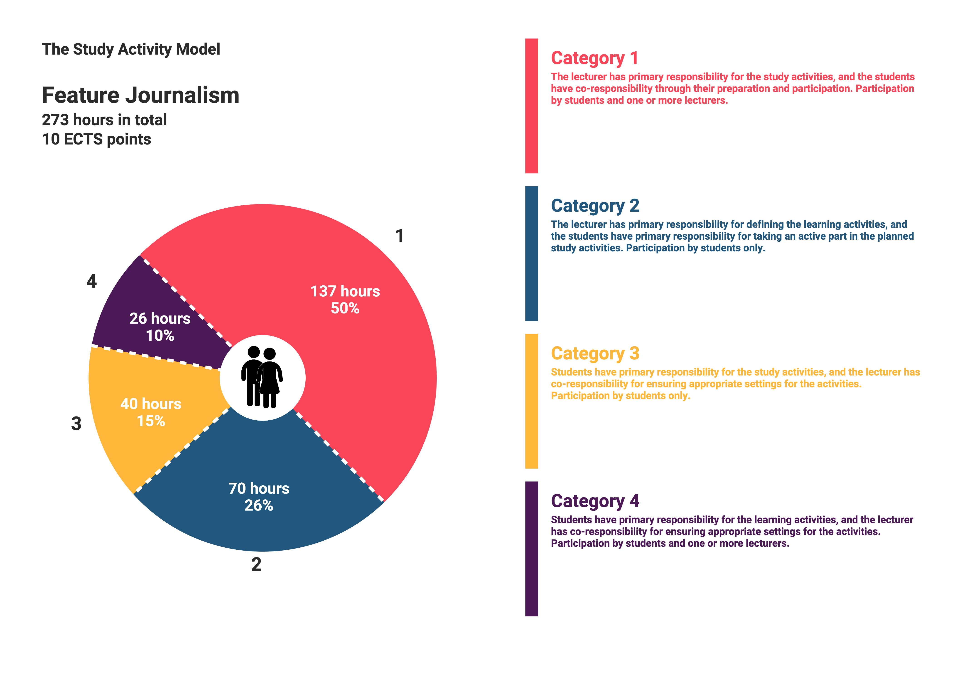

**Course Description**

**People Behind the figures**

**Number of ECTS Credits: 10 ECTS**

**Aims**

* to encourage students to understand, reflect and report on the statistics of a country.
* to make the students focus on how to find relevant stories in statistics and unfold them with human sources for an interesting video story
* to discuss the challenges the students might meet in making stories based on statistics

**Learning outcomes**

On completion of the module, students are expected to have achieved:

**Knowledge**

* on the database Statistics Denmark and the purpose of it, as a point of departure for journalistic work
* on methods for finding and understanding statistics for journalistic storytelling
* on how to work creatively with statistics
* on different ways of presenting statistics in video storytelling
* on the responsibilities, hereunder ethical choices journalists must take in producing video stories for different target groups

**Understanding**

* understand how to read and use statistics for journalism
* understand how to unfold specific statistics in journalistic video stories
* understand the variety of ways to include statistics in a video story

**Skills**

The students should be able to

* find and understand different statistics in Denmark
* use different methods for analysis of statistics
* choose creative ways in presenting statistics in a video story
* be aware on ethical values in reporting
* be aware, and reflect on own biases and stereotypes in the approach and production of journalistic stories

**Pedagogical and didactic approaches**

Lectures with interactive discussions and exercises in groups based on the readings and relevant videos. Group work and peer feedback are the working methods for all the video assignments, including individual tuition in groups. Re-edit the video assignment based on the feedback given by teachers and peers.

**Working methods:**

Research methods, production planning and technical production of journalistic video feature stories.

Lectures, groupwork, class discussions, self-study of texts and video features and documentaries.

**Preconditions for exam:**

Attendance: Students must actively attend all scheduled classes and class activities, as described in the calendar. A 90 per cent attendance is required, calculated one working week prior to finalisation of the course.

Participation: All group work and other mandatory activities. Submission of pre-script, video, final script and feedback. Includes also coaching, preparation tasks, class presentations, and feedback related to the assignments.

Compensation: A possibility of compensation assignments applies in the event of allowed absence, cf. point 6.2.2 in the DMJX Journalism BA Curriculum.

**Exam/Grading:**

Grading by the Danish 7-point grading scale.

The grade is based on a pre-script, video assignment, final script and written peer feedback.

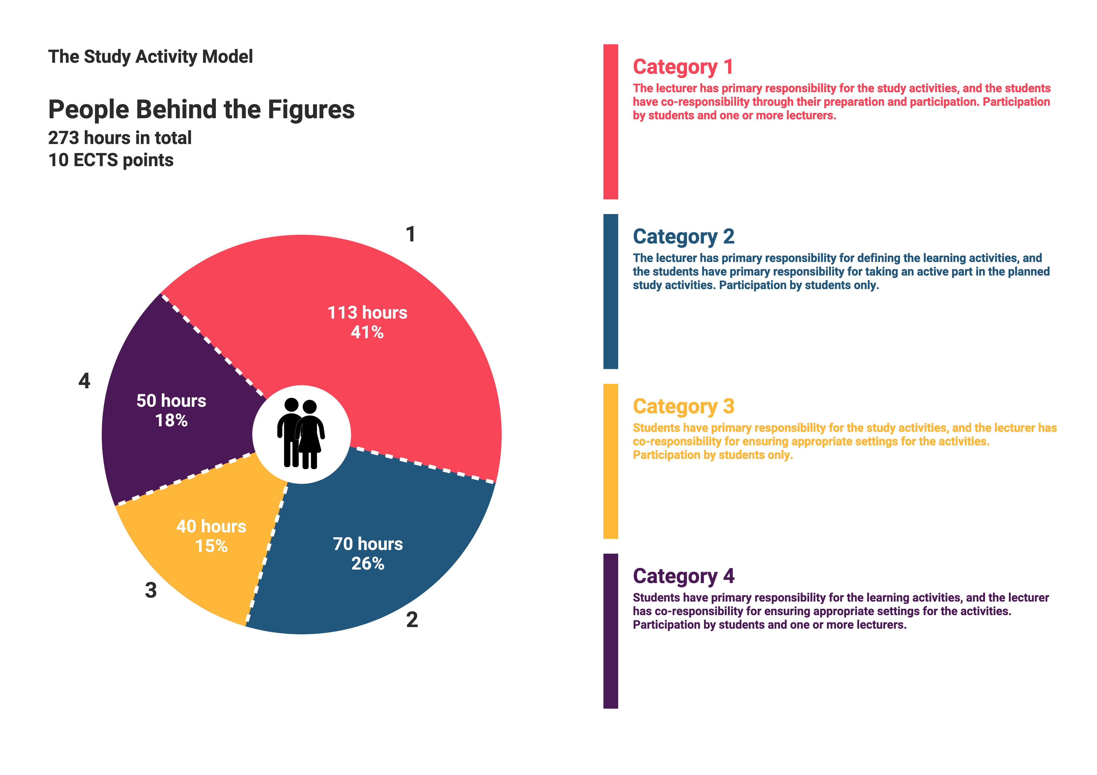

**Course Description**

**Documentary Production: 10 ECTS**

**Aims:**

The final project aims to:

* Introduce and discuss the different forms of documentary genres and journalistic approaches.
* Record and edit a 12-15 min journalistic documentary video
* Give qualified feedback to opponent group and re-edit the documentary from the feedback given
* Teach the students to choose form and visual aesthetics that merge with the chosen documentary genre.
* Enable students to reflect on their own working process, including ethical production dilemmas, and to discuss and implement theoretical approaches to their own journalistic product.

**Learning outcomes**

On completion of the module, students are expected to have achieved:

**Knowledge**

* Know the value of idea development
* Know how to follow and change a production plan accordingly
* Know how to record and edit a 12-15 min journalistic documentary
* Know to work with sources over a long time span
* Know to reflect on and analyse professional and student video productions
* Know how to re-edit a piece according to the feedback given

**Understanding**

* Understand the value of field research and pre-interview sources
* Understand the value of working with a script as a tool for structuring a documentary
* Understand how to do realistic production planning for a long term project
* Understand to hold contact with key sources during the production process
* Understand the importance of source critique and verification in the journalistic working process

**Skills**

* Identify and discuss the different forms of documentary genres and journalistic approaches.
* How to cope with challenges in a documentary production ex. group work, handling sources, re-scheduling appointments etc.
* Practical experience in working with a manuscript as working tool for structuring the documentary
* Practical experience in planning, recording and editing a 12-15 min journalistic documentary video
* Know how to choose form and visual aesthetics that merge with the chosen documentary genre. Try out different ways of creative video storytelling
* The students will know how to reflect on their own working process, including ethical production dilemmas, and to discuss theoretical approaches to their own journalistic product.

**Pedagogical and didactic approaches**

Lectures with interactive discussions and exercises in groups based on the readings and relevant videos. Group work and peer feedback are the working methods for all the video assignments, including individual tuition in groups. Re-edit the video assignment based on the feedback given by teachers and peers.

**Working methods:**

Camerawork, editing. How to give and receive analytical and constructive feedback.

Lectures, groupwork, class discussions, self-study of texts and video features and documentaries.

**Preconditions for exam:**

Attendance: Students must actively attend all scheduled classes and class activities, as described in the calendar. A 90 per cent attendance is required, calculated one working week prior to finalisation of the course.

Participation: All group work and other mandatory activities. Submission of synopsis, video, final script and feedback. Includes also coaching, preparation tasks, class presentations, and feedback related to the assignments.

Compensation: A possibility of compensation assignments applies in the event of allowed absence, cf. point 6.2.2 in the DMJX Journalism BA Curriculum.

**Exam/Grading:**

Grading by the Danish 7-point grading scale.

The grade is based on a synopsis, pre-script, video assignment, final script, and written peer feedback.

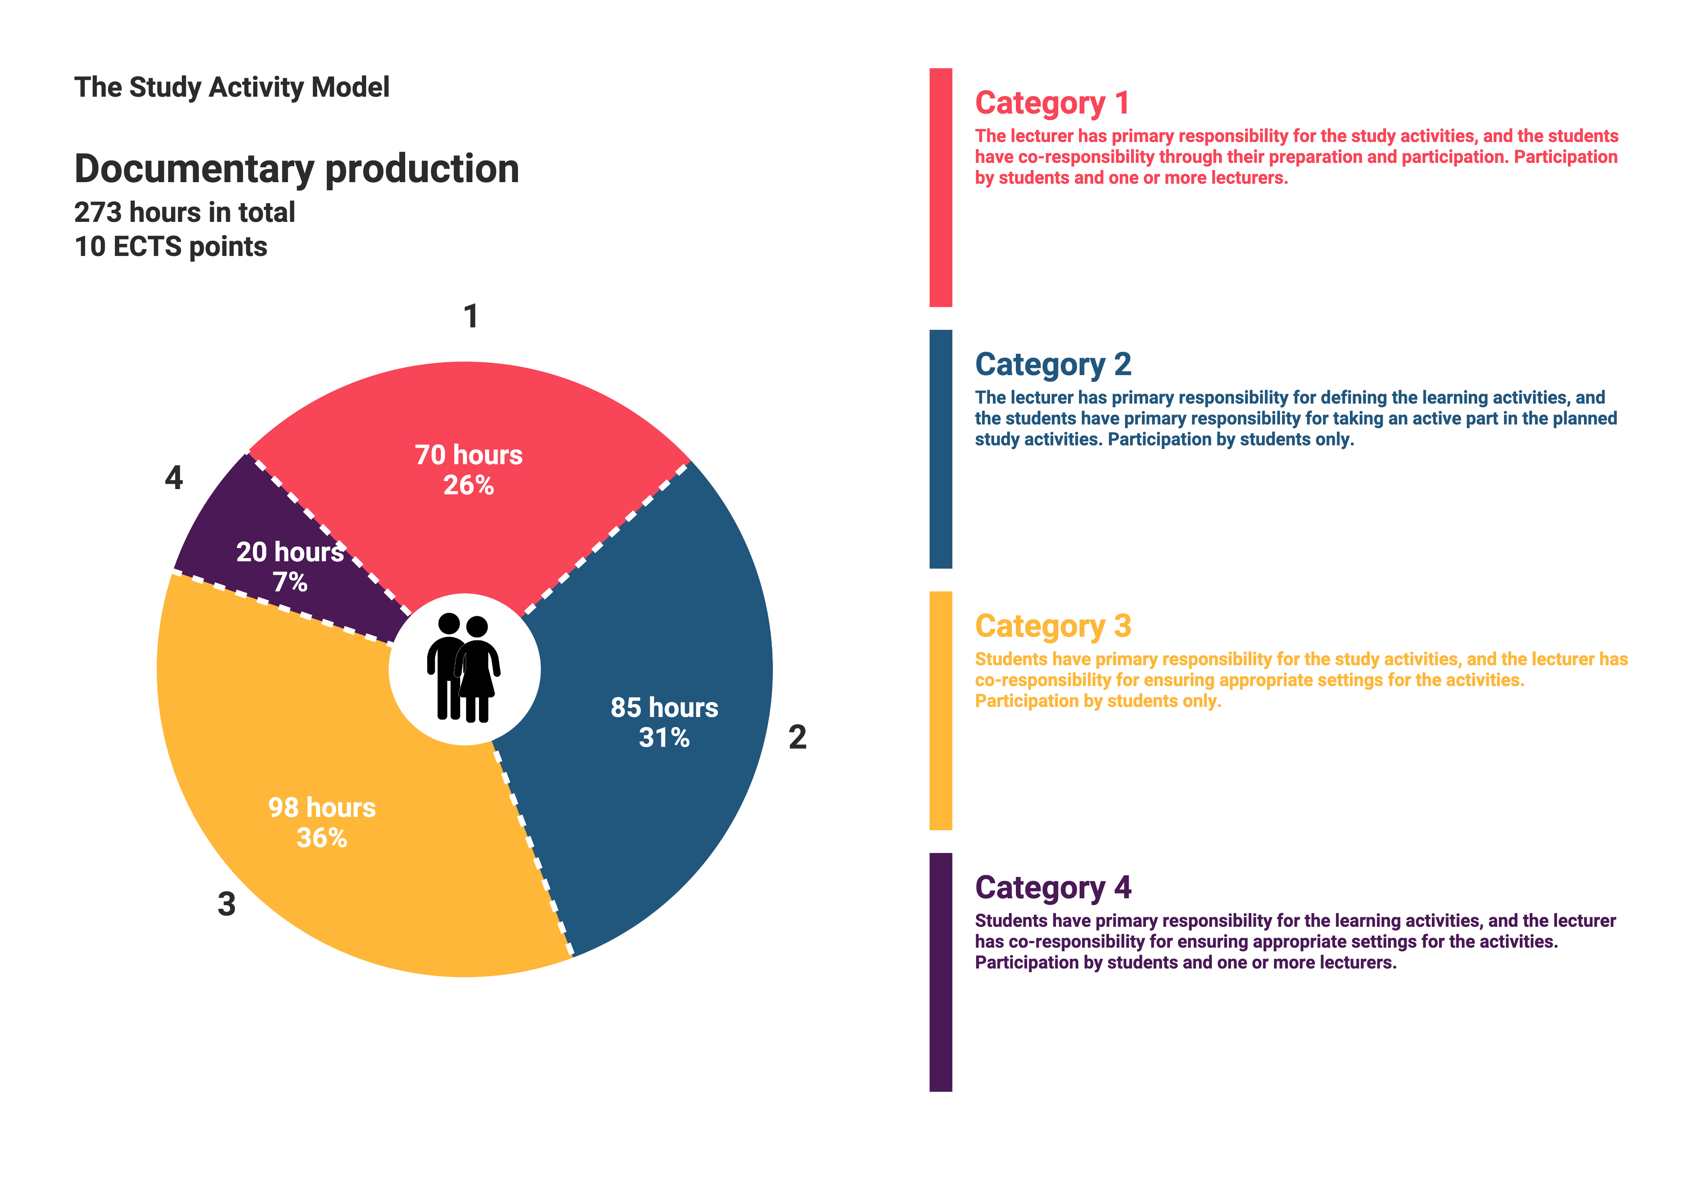

HB 9.6.2023