Danish School of Media and Journalism
TV and Media Production
Course description
Fall semester 2023
Documentary Production
3rd semester

Number of ECTS Credits: 10

Aims:
The course will give the students theoretical and practical knowledge on the production of documentary films. Based on theoretical texts on the definitions and conventions of the genre, combined with film-analysis and discussions on contemporary developments in applied means of expression among documentary film makers, students should obtain an in-depth understanding of the genre.

Aiming at taking their visual and storytelling skills on to advanced level students will alongside the theoretical tuition, produce their own short documentary films, actively working with the dramaturgic tools from structure and character development to storytelling mode and visual expression. Furthermore, the course will train students story planning skills both concerning pre- and postproduction.

On the technical side the course will encompass workshops on advanced editing, sound, and colour grading.

Pedagogical and didactic approaches:
The course combines lectures and theoretical workshops with practical exercises and assignments, both individually and groupwise, creating a common language and frame of reference for the students. This combination is aimed at translating theoretical knowledge into action.

The work of student groups developing, researching, casting, producing and post producing a short documentary will be followed closely in repeated supervision sessions conducted by tutors. This will be supplemented by self-organized peer supervision and feedback, which will advance students ability to reflect on the strengths and weaknesses of their own work and that of fellow students. The writing of a film concept secures precision in storytelling, and reflection of the creative process.

The course will be finalized with a common screening and feedback session for the entire class, to create a common completion of the course where students can learn from and reflect on both their own experience and that of others. Furthermore, students must, at the end of the course, hand in a reflection report on the working process.

Production groups will consist of two to four students, and the groups will be put together by students themselves. This is aimed at securing the best possible motivation and cooperation in the demanding work process of the course.

Working groups will be either Danish or international. The decision not to integrate international and Danish students is an effect of repeated complains on language difficulties in the working process in mixed working group in evaluations of previous courses from Danish as well as international students.

Tuition in class will be supported using e-learning tutorials.

Tools:
C100 cameras, microports, Adobe Premiere Pro

Learning outcomes:
The students will obtain the following during the course:

Knowledge and understanding:
- Understand and reflect on the documentary genre and its development through time.
- Know, understand, and use of expressive modes of the documentary genre.
- Know, understand, and use different dramaturgic and storytelling models.

Skills:
- Plan, shoot and edit documentary productions with a duration of up to 10 minutes.
- Understand and work with sound and colour grading in post-production.

Competences:
- Entering group processes and give and receive guidance to and from fellow students during a production process in a constructive way.
- Overlooking the entire production process of at short documentary, encompassing idea-development and casting.
- Mastering communication with and guidance of contributing characters both before, during and after filming.
- Reflecting on their own performances and productions, and those of fellow students.

Literature (to be purchased before the course begins):
Andersen, N. P. (2021). Order in Chaos. Harper Collins Publishers.

Literature (hand out):
Nichols, B. (2017). Introduction to Documentary. Third Edition. Indiana University Press. Pages 1-12 and 22-23.

Nichols, B. (2010). Engaging Cinema. W.W Norton & Company. Pages 99-130.

Bernard, S. C. (2011). Documentary Storytelling, Creative Nonfiction on Screen. Fourth edition. Focal Press. Pages 37-52.

Literature (available online):
LinkedIn Learning video tutorials:
- The importance of understanding exposure (part 1). Ben Long
- Premiere Pro CC 2022 Essential Training: The Basics. Ashley Kennedy
- Fixing color and exposure problems in video with Premiere Pro. Richard Harrington.

Preconditions for the exam:
Fulfilment of attendance requirements and/or submission of assignments and projects etc. are required for being allowed to take an examination. In this course the preconditions are:
Participation: Participation in group work, supervision and feedback sessions is required, in addition to individual and group assignments.
Compensation: If a student does not participate in the provisions above the student must hand in compensation assignments as a precondition for exam.

Exam:
Graded using the ECTS scale with an internal examiner.
Documentary Production ends with a final assignment carried out in groups of two to four students. The final assignment consists of two equally important parts: An original media production and a written assignment. To ensure individual grading, the contribution of each group member must be noted, as there is no oral examination. The students’ writing and spelling skills will influence the grading.

Study Activity Model:
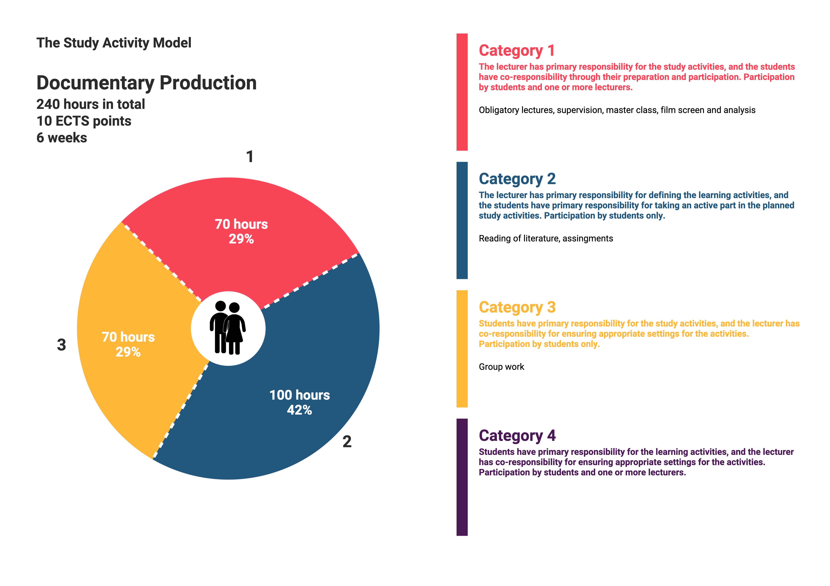

Approved by BBS, 2023-08-14.

