Danish School of Media and Journalism
TV and Media Production
Course description
Fall semester 2023
Corporate Communication
3rd semester

Number of ECTS Credits: 10

Aims:
The main goal of the course is to equip the students with the skills necessary to develop communication projects for companies and organizations based on an understanding of their communication strategies and values.

The students will gain knowledge of the theories and concepts on which organizational and strategic communication is based, including tools for analysing communication products, markets segments and target groups.

On the practical level students will work in close cooperation with external clients, with the aim of gaining an understanding of the "real life" framework of the development and production of communication tasks in companies and organisations. Students will produce an audiovisual production that solves a concrete communication need for the client.

Pedagogical and didactic approaches:
The teaching will be a mixture of lectures, team discussions, group work, workshops, and self-study. The students must expect preparation for the teaching.

The groups will be set by the teacher.

Tools:
Literature, camera, sound and editing equipment, directing and production guidelines.

Learning outcomes:
The students will obtain the following during the course:

Knowledge and understanding:

Students will:
- be able to provide independent analysis of communication products based on the theories studied in the course and be capable of identifying and analysing how communication strategies and values are manifested in specific communication products,
- be able to understand the differences between corporate communication and journalism,
- be able to understand the framework for handling communication tasks in a corporate framework,
- have awareness for communications strategies.

Skills:

The students will
- be familiar with various genres of external corporate communication,
- be able to apply and transform theoretical concepts into operational tools for developing and producing communication work,
- be able to convert corporate communications strategies and values into guidelines for developing and producing communication work,
- have gained hands on experience from cooperating with an external client and will have gained an understanding of the "real life" framework of the development and production of communication tasks in companies and organisations.

Competences:

The students will
- be capable, firstly, of developing ideas and creating concepts based on requirements outlined by the client and, secondly, be able to translate these into a manuscript and production plan that can serve as a framework for collaboration with the client.
- have experienced the balance between, on the one hand, respecting the client’s needs and requirements and, on the other hand, challenging the assignment and the client with insightful and creative ideas.

Literature (to be purchased before the course begins):
Guldbrandsen, I. T and Just, S. N. (2020). Strategizing Communication. 2nd. Edition. Samfundslitteratur.

Literature (hand out):
Cornelissen, Joep (2020). Corporate Communication – A Guide to Theory & Practice 6th edition. SAGE. Pages 3-16, 18-27 and 34-35.

Preconditions for the exam:
Fulfilment of attendance requirements and/or submission of assignments and projects etc. are required for being allowed to take an examination. In this course the preconditions are:
Participation: Participation in group work and supervision is required
Compensation: If a student does not participate in group work and supervision sessions the student must hand in compensation assignments as a precondition for exam.

Exam:
Graded using the ECTS scale with an internal examiner.
Corporate Communication ends with a final assignment carried out in groups of three to four students. The final assignment consists of two equally important parts: An original media production and a written assignment. The students’ writing and spelling skills will influence the grading. The exam is an oral examination of the groups and has a maximum duration of 10 minutes per student, including voting.

Study Activity Model:

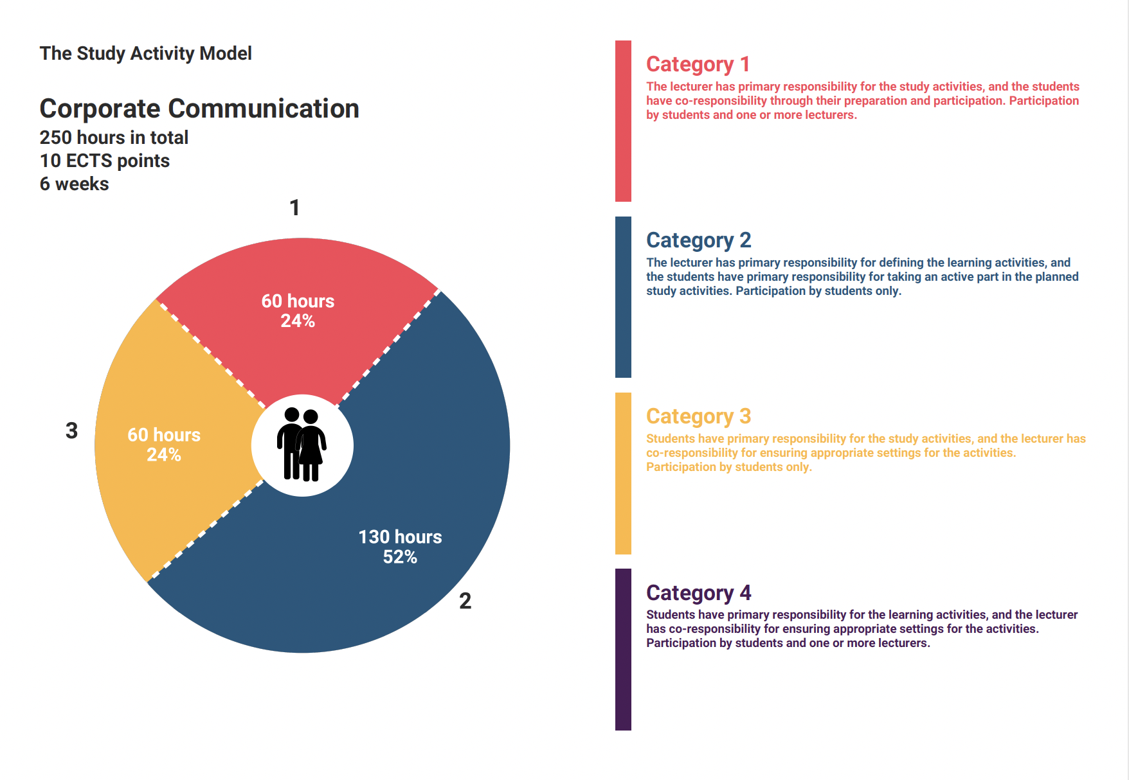

Approved by BBS, 2023-08-14

