# Study Guide

International Semester Programme

***Photo 1: The Language of Photojournalism***

**at The Danish School of Media and Journalism - Aarhus**

#### Autumn semesters: August (week 34) - December (week 50)

#### Spring semesters: January (week 5) - June (week 24)

The Saravani family has lived in Rige Mouri village, Helmand town, Iran for more than 100 years. This village, which once was rich and fertile, is now covered with sand and dust. Not long ago, it was a village near the river. In the past, more than 500 families (3000 people) lived in the village, but now only 17 families have remained.

From the story “An Elegy for the Death of Hamun” by Hashem Shakeri – made in 2018.

The semester in Denmark offers you a chance to combine photojournalistic training with intensive study. The programme focuses on the language of photojournalism combined with journalistic disciplines like writing, video- and sound production.

As a result of this semester, you can achieve the following goals:

* Learn how to use the visual language of photojournalism to tell stories which have an impact on the readers
* Experience how you can edit and layout your picture stories in a professional way
* Create a magazine in co-operation with your classmates
* Learn how to make advanced and intimate portraits showing more than the face of a person
* Get knowledge on video and sound production with DSLR cameras
* Work in a group to create a video documentary
* Increase your understanding of the problems and possibilities the Scandinavian welfare state model is facing in modern Europe by living and working in Denmark
* Grow as a prospective photojournalist by working and studying in an atmosphere that combines practical teaching with academic study
* Create life-long professional and personal bonds by being part of an international group of students from all over the world

Examination rules and regulations:

Link: [Examination rules and regulations](https://cpb-eu-w2.wpmucdn.com/www.mediajungle.dk/dist/6/11891/files/2020/09/Examination-rules-and-regulations_Bachelor.pdf)

Here you can read about rules for participation, deadlines, re-examination, and assessment.

|  |  |
| --- | --- |
| **Study Load/credit** | **ECTS** |
| Introduction - DMJX and Danish culture  Photojournalism in general | 10 |
| Magazine Project | 10 |
| Video Documentary | 10 |
| TOTAL | 30 |

**Attendance:**

All lectures, assignments, group work, coaching and evaluations of assignments are mandatory.

If for some reason students cannot attend, they are expected to notify the school. In case of illness, they may be asked to hand in a medical certificate (for further information see the Student Handbook)

**Exam/Grading:**

The program is a full course load semester programme. All assignments are graded in the Danish grading scale and the ECTS grades: A - F.

**The overall programme**

The international photojournalism semester programme runs every semester. Please notice that course contents and teachers may change from semester to semester. The following gives an overview of the semester.

**Media platform: *Photojournalism in printed media and on the Internet***

The semester will focus on both photojournalism in the printed media and photojournalism on the Internet. There will be basic courses in handling layout and handling video and sound. We also focus on the combination between picture and text and therefore the students will be asked to write smaller articles together with their pictures.

**Aims:**

* Acquire a transnational perspective on issues that are of critical importance in today's society: national, regional and global
* Enhance photojournalistic awareness of national versus international reporting
* Give inspiration to work internationally
* Build a solid professional foundation for future careers in photojournalism

**Learning outcomes:**

Knowledge and understanding of:

* the visual language of photojournalism to tell stories which have an impact on the readers
* combining video and sound video documentaries
* editing picture stories to fulfil the story
* presenting the whole story in a professional layout
* advanced portraits showing more than the face of a person
* the impact of culture and identity on the practice of photojournalism

**Skills**

Students will be able to:

* structure, plan and carry out photojournalistic research at the international level
* communicate effectively with a diverse audience
* identify new and critical angels in traditional stories
* manage resources and time effectively
* work in a self-organized way, individually and in groups
* give and receive constructive feedback

Course:

Introduction Programme

**Lecturers:** Head of International Department, Inger Munk and guest lecturers

**Graded:** as part of the Photojournalistic Methods course

**Outline:**

This course provides students with an insight into political, financial, social, and cultural aspects of the Danish society through introductions to different institutions, structures, stereotypes and media. The introductions aim at making both Danish and international students familiar with their new study environment as quickly as possible.

International students will also be offered a Danish language course.

**Topics**

* Introduction to the semester programme
* Introduction to teaching methods, library and equipment at DMJX
* Introduction to Danish language course at different levels
* Cultural event introducing all nationalities participating in the international programmes
* Introduction to Danish politics and the welfare system including an excursion to the City Hall
* Introduction to Danish media
* Introduction to Studenterhus Aarhus (the Student House Aarhus)
* Introduction to digital cameras and editing tools
* Lecture on stereotypes

**Literature**

See <http://www.denmark.dk/en> for a general information about Denmark.

See <http://www.kl.dk/English/> about the Danish Local Government System

See <http://www.aarhus.dk/da/omkommunen/english.aspx> and

www.businessregionaarhus.com for general information about Aarhus.

Perry Hinton: Stereotypes, Cognition and Culture, Psychology Focus, 2000 Chapter one

Janet B. Ruscher: Prejudiced Communication, The Guilford Press, 2001, Chapter 6

# Course:

# Photojournalistic Methods

**Lectures:** Ass. professor Mads Greve and guest lecturers

**ECTS:** 10

# Aims

The workshop aims to:

* Enable the students to master basic methods in photojournalism, such as picture editing, using the visual effects of photography etc.
* Introduce and discuss specific methods in how to use photography as a story telling media.
* Introduce and train photojournalism.

**Learning outcomes**

Knowledge about

* the different genres within photojournalism and how to work with them.
* the techniques and rules of workflow and digital picture editing.

the methods of both editorial and advanced portrait photography.

* how to make basic reportage photography. And how to put several pictures together for a picture story.
* a variety of photojournalists and their work.

*Understanding*

* How the different visual effects influence the story telling
* The ethical considerations when working as a photojournalist

### Skills

*Discipline specific*

* The students will know how to find and produce picture stories.
* The students will be able to use the right methods in visual story telling.
* The students will make portraits that both have a visual impact and tell something about the person.
* The students will give mutual feedback in order to improve their stories and skills

*Transferable*

* The students will gain a good understanding of how to work with photojournalism in a lot of aspects.
* The students will gain a lot of practical experiences with both making pictures and discussing photojournalism.
* Ability to reflect on own and other photographers’ work

**Literature (to be bought)**

Pagter, Søren. The Essential Image. Forlaget Ajour 2018.

Chapter 1 to 8

**Preconditions for exam:**

Attendance: Students must actively attend all scheduled classes (appears in the programme). Time of status is September the 12th. Attendance is a precondition for submitting the final assignment.

Participation: All group work and other mandatory activities which are portrait and reportage assignments. Participation is a precondition for having the final assignment assessed.

Compensation: A possibility of compensation assignments applies in the event of allowed absence, cf point 6.2.2 in the DMJX Photojournalism BA Curriculum.

**Exam/Grading:**

Grading by the Danish 7-point grading scale. The grade is based on a short documentary assignment, individually submission.

**Study activity:**

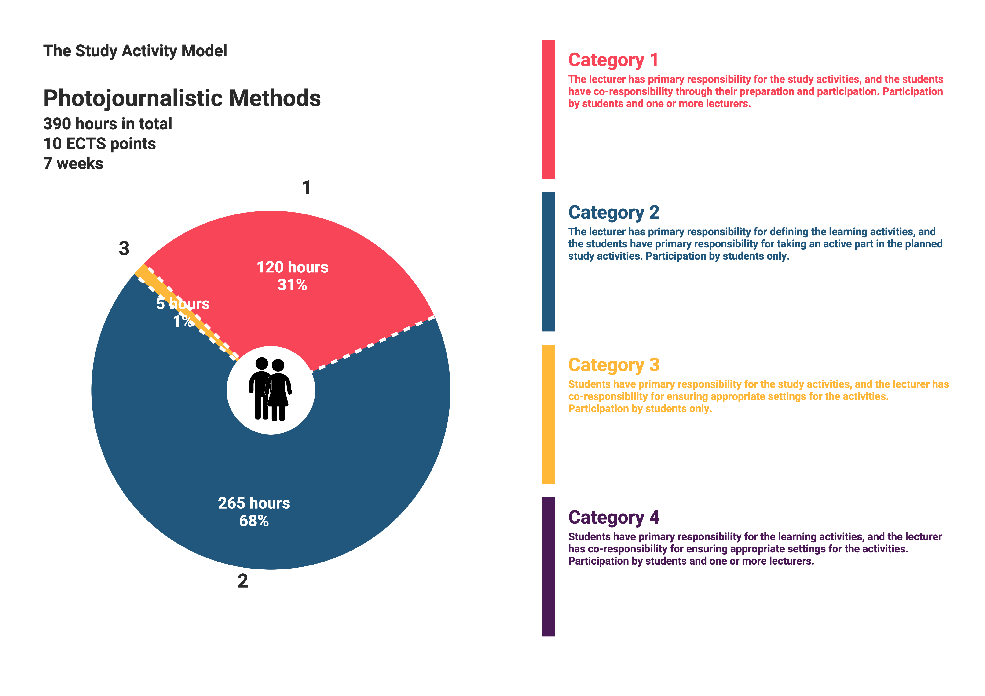

**Course:**

**Magazine project**

**Lecturer: Mads Greve**

**ECTS:** 10

**Aims**

* To work in depth with one picture story
* To create a combination of photography, text and layout

**Learning outcomes**

On completion of the module students are expected to have achieved:

## Knowledge

* how photography and text work together
* how to research and plan the production of a picture story
* how to balance the pictures in the layout
* how to work together as an editorial group making a magazine

*Understanding*

* to recognize how different pictures in a story are needed for a complete story
* understand the importance of balanced reporting and accuracy in photojournalism
* understand how the choice you make as a photographer influence on the story

## Skills

*Discipline specific*

* Handle all aspects of planning a photojournalistic reportage
* To critically analyze the use of different pictures in the story

*Transferable*

* Strengthened sense of how to tell stories within photojournalism
* Strengthened confidence in using own skills

**Literature (to be bought)**

Pagter, Søren. The Essential Image. Forlaget Ajour 2018.

Chapter 9 to 12

**Preconditions for exam:**

Attendance: Students must actively attend all scheduled classes (appears in the programme). Time of status is October the 14th. Attendance is a precondition for submitting the final assignment.

Participation: All group work and other mandatory activities which are synopsis and layout assignments. Participation is a precondition for having the final assignment assessed.

Compensation: A possibility of compensation assignments applies in the event of allowed absence, cf point 6.2.2 in the DMJX Photojournalism BA Curriculum.

**Exam/Grading:**

Grading by the Danish 7-point grading scale. The grade is based on a Magazine story including texts, pictures and layout.

**Study activity:**

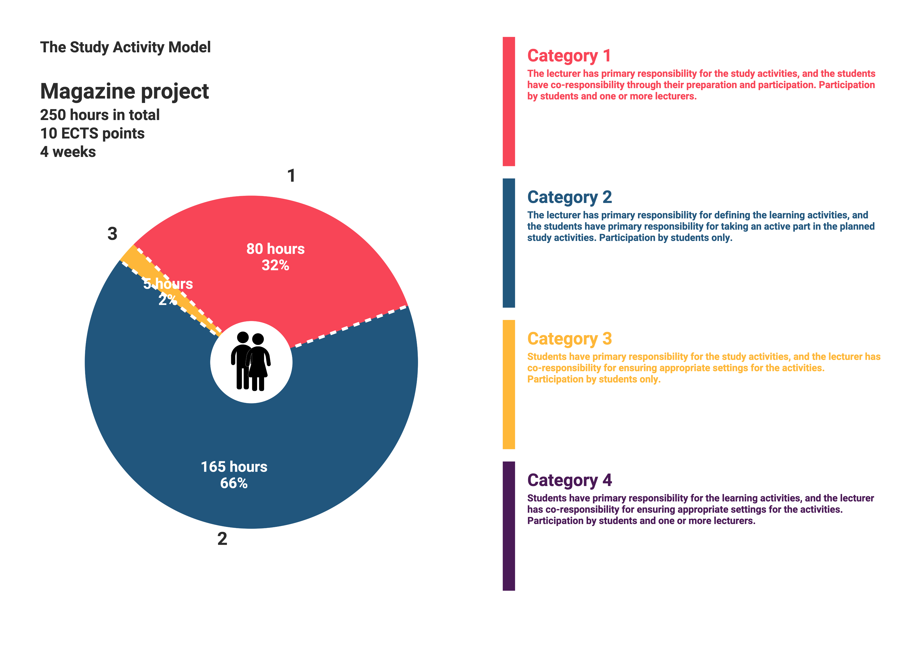

Course:

**Video Documentary**

**Lecturer:** Guest lecturer Simon Sticker

**ECTS:** 10

**Tools:**

DSLR-Cameras

Sound recordings

Final Cut Pro X

**Learning outcomes**

On completion of the module students are expected to have achieved:

Knowledge:

* How Video stories are different from stories with photos and text
* How to construct different video documentaries
* How to plan a video documentary
* How to trust the credibility of a video documentary

Understanding:

* Video and sound recordings with DSLR Cameras
* Video and sound editing using Final Cut Pro X Video
* How to plan a story board before the editing process
* How to combine sound and photos in a video documentary

Skills:

* Acquire knowledge about new techniques
* Create trust to the people in the story
* Work with reporting elements in a video documentary
* Cooperation in groups on a common production
* Give and receive feedback
* Able to reflect on own choices and opt-outs

**Literature (will be handed out)**

Bernard, Sheila Curran. Documentary Storytelling, Creative Nonfiction on Screen, 4th edition (2016). Focal Press.

Chapters: 1, 2, 3, 6, 8, 11 og 12

AVailable link:

<https://www.documentarystorm.com/>

**Preconditions for exam:**

Attendance: Students must actively attend all scheduled classes (appears in the programme). Time of status is December the 5th. Attendance is a precondition for submitting the final assignment.

Participation: All group work and other mandatory activities which are small technical assignments consisting of sound, video and editing. Participation is a precondition for having the final assignment assessed.

Compensation: A possibility of compensation assignments applies in the event of allowed absence, cf point 6.2.2 in the DMJX Photojournalism BA Curriculum.

**Exam/Grading:**

Grading by the Danish 7-point grading scale. The grade is based on a short video documentary, submitted in groups of two, or individually. It must be clear who is responsible for which part of a group submission. Students receive individual grades.

**Study activity:**

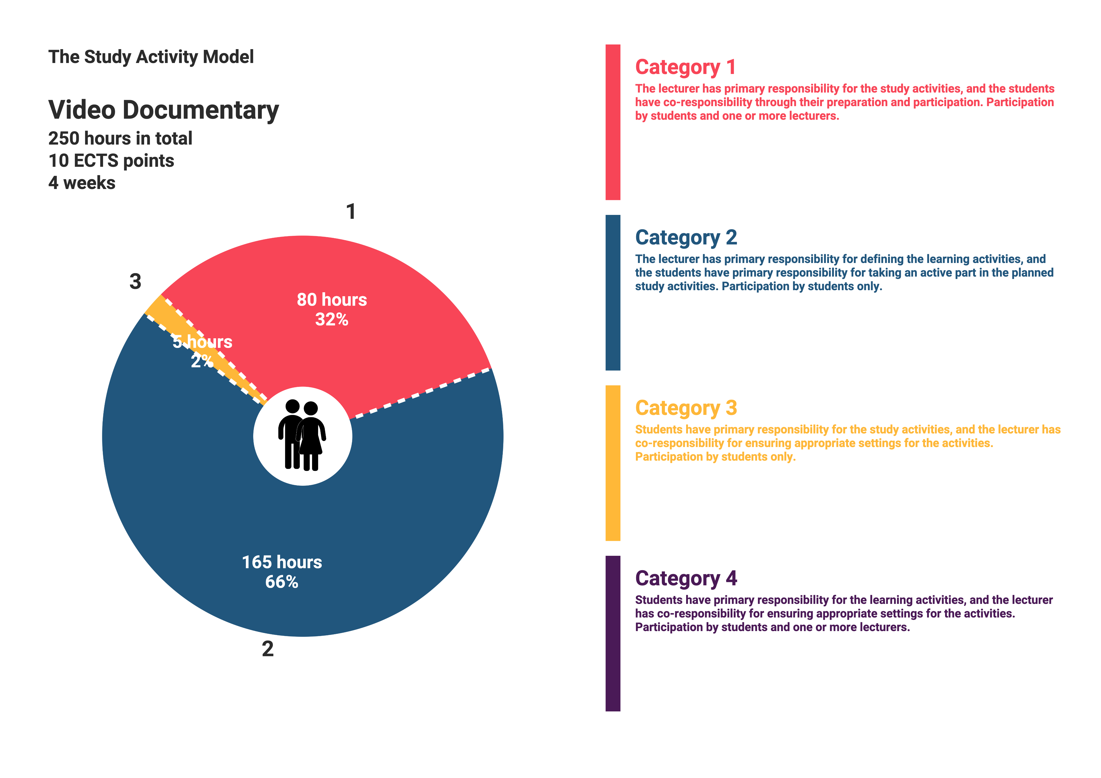

**Additional lectures and courses**

Guest lectures at the Danish School of Journalism will be offered in the programme.

There will be the possibility for excursions and for travel for reporting projects. (At students' own expense).

Throughout the course additional photojournalism lectures will be held across all semesters at the school. These lectures will always be held in English and the international students are invited to participate in the lectures.

##### Programme Policy

At the Danish School of Media and Journalism we strive to uphold the standards of excellence in Journalism.

##### We require the students to uphold the IJF standards of journalism in all their work according to The IFJ Declaration of Principles on the conduct of journalists adopted by the 1954 World Congress of the IFJ and amended by the 1986 World Congress (see [www.ifj.org](http://www.ifj.org) and Student Handbook).

**Excursions and travels**

There will be time for individual excursions and travelling for reporting projects (at students' own expenses).

Facilities at the Danish School of Media and Journalism

(Please consult the Student Handbook for more details about the facilities.)

**Phone:**

We expect you to bring a mobile phone. For long distance calls, we advise students to buy global phone cards or use Skype.

**Cameras - DMJX equipment:**

We expect students to bring their own basic camera equipment, but students may borrow the school’s cameras for some assignments, and students have access to editing facilities. Students have access to a C-41 developing machine where they can develop analogue films.

**Computers:**

The school has computers (Mac) for the use of students, but we recommend that you bring your own laptop. You can use the school’s wireless network for free.

Use of the computers evenings and weekends is possible but requires an access card (deposit 200 DKK).

**Email**:

You will be granted an email address at the school, to be used during your stay in Aarhus. The email address is needed to receive relevant messages, access course material, and submit assignments. We expect you to check your email at least daily. The email address also allows you access to the school’s computers, printers and wifi.

The school email account will be closed one month after the programme has ended.

**Photocopiers and printers:**

Each student gets a certain number of free prints. Copy cards for photocopies and additional prints can be purchased from the reception desk.

**Library:**

The school’s library containing the Danish Media Archives is at your disposal. There are also computers specially set up for international wire services and databases. The State and University Library at Aarhus University is also open for use with a Danish cpr-number, or you can order its material through the DMJX library.

**Electronic classroom and publishing:**

The school uses **Itslearning** (virtual classroom) for study related material and communication.

For online publishing purposes (internal and external), the school’s WordPress-based Mediajungle-sites are used. Some productions are published online and/or in collaboration with external partners.

**For further information**

See Student Handbook:

[Link to student handbook](https://www.dmjx.dk/international/coming-denmark)

Staff

**Mads Greve** [mg@dmjx.dk](mailto:mg@dmjx.dk)

Photojournalist, Ass. professor, DMJX

Educational background:Photojournalism, DMJX

Course: Photojournalism in general

**Anna Nejrup** [anna@dmjx.dk](mailto:anna@dmjx.dk)

International Coordinator, DMJX

Educational background: MA in French and English from the Aarhus School of Business

International student coordinator

**Søren Pagter** [sp@dmjx.dk](mailto:sp@dmjx.dk)

Photojournalist, Ass. professor, Head of the Photojournalism Dep. DMJX

Educational background: Photojournalism, DMJX

Course: Reportage project and overall content

HB 9.6.2023